Create Oracle 19c Database Procedure

Marsh DBA Group

Document Revision History

|  |  |  |  |
| --- | --- | --- | --- |
| **Revision Number** | **Author** | **Revision Date**  **(mmm dd, yyyy)** | **Revision Description** |
| 0.1 | Pao-Gen Wang | March 23, 2020 | Initial revision |
|  |  |  |  |
|  |  |  |  |

1. Prerequisite

Have proper ASM disk groups in place and enough available space before creating a new database. For example,

GEN_PROD_DATA01

GEN_PROD_FRA01

GEN_PROD_TEMP01

1. Create New DB

Start an X server process on the local machine. (xming is a good free product for this)

Log onto server using an individual id and copy the .Xauthority file to /tmp/<userid>.Xauthority (i.e. /tmp/pwang.Xauthority)

cp .Xauthority /tmp/<userid>.Xauthority

Change permissions on /tmp/<userid>.Xauthority to be 777

chmod 777 /tmp/<userid>.Xauthority

Sudo to become the oracle user using the following command:

sudo –u oracle –i

Copy the .Xauthority file from the tmp location to the oracle home directory, i.e, /home/oracle:

cd /opt/oracle

cp /tmp/<userid>.Xauthority .Xauthority

Run profile

. ./.profile (can copy usdfw23db18vcn1:/home/oracle/.profile to the target DB server to be created for new 19c database.)

(If no Xwindow shows up for any reasons, may try to remove /home/oracle/.Xauthority file, re-login and repeat the above steps.)

cd /opt/oracle/product/19/db/bin

**./dbca**

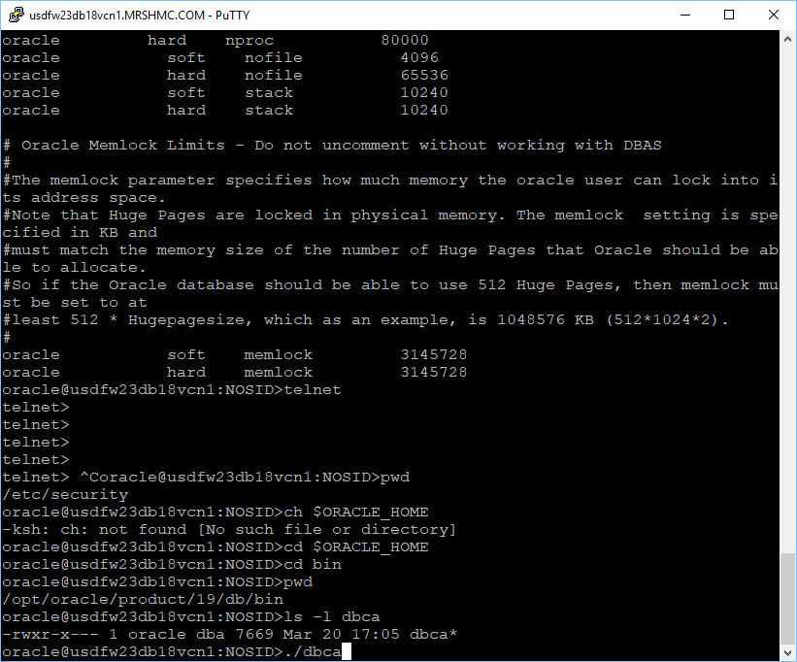

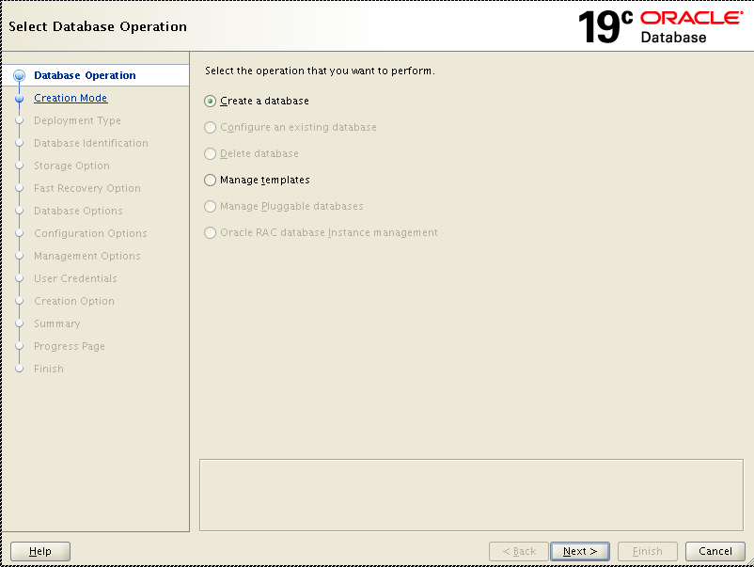

On the first screen select “Create a Database” and click on the “Next” button.

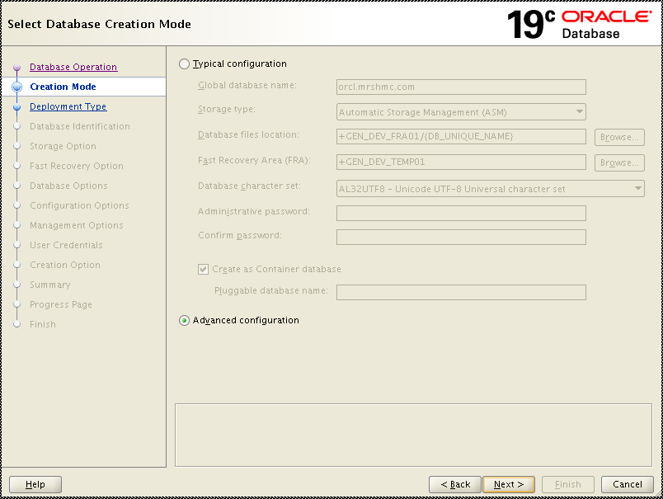

On the next screen select “Advanced Configuration” and click on the “Next” button.

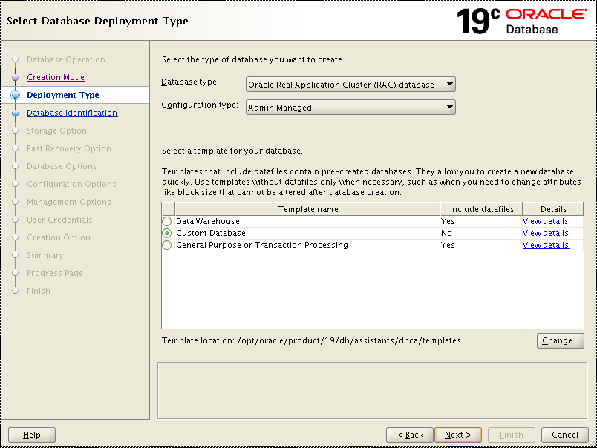

Click “Custom Database”. Select the Custom Database option to control what options will be created/installed into the database as shown below. Click “View details” to see what have been selected. (We will disable the components we do not use them or no license for them later.)

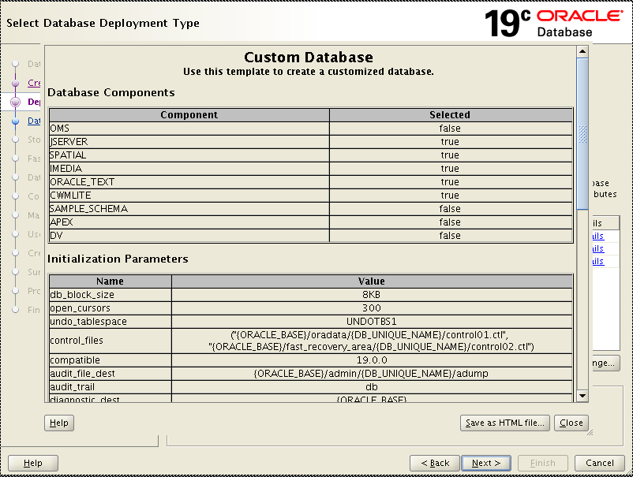

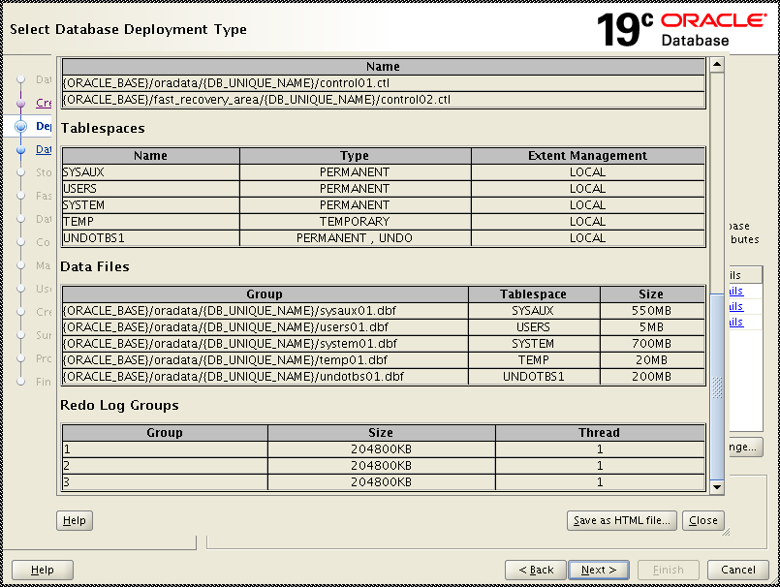

Click on “Close” button and then the “Next” button.

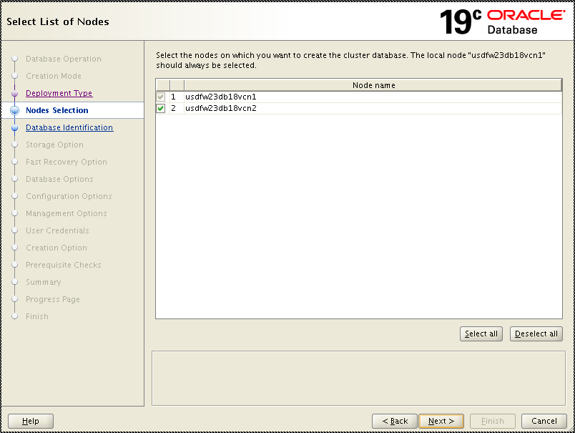

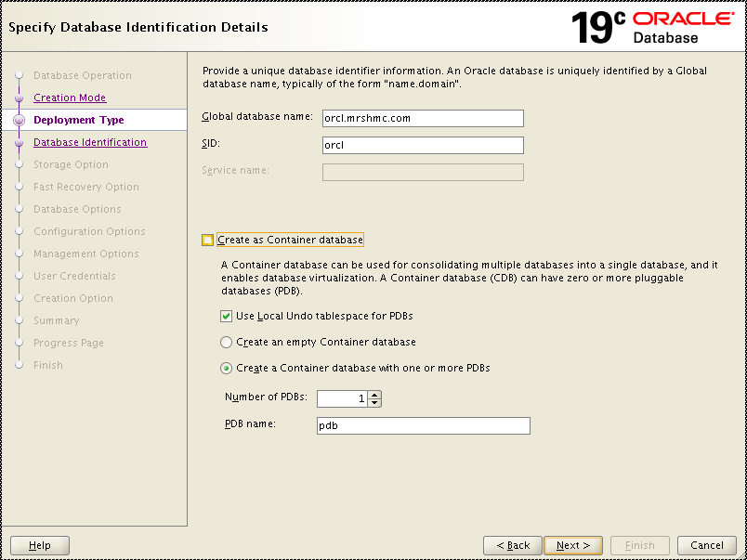

On the Database Identification screen **do not check** the “Create As Container Database” check box

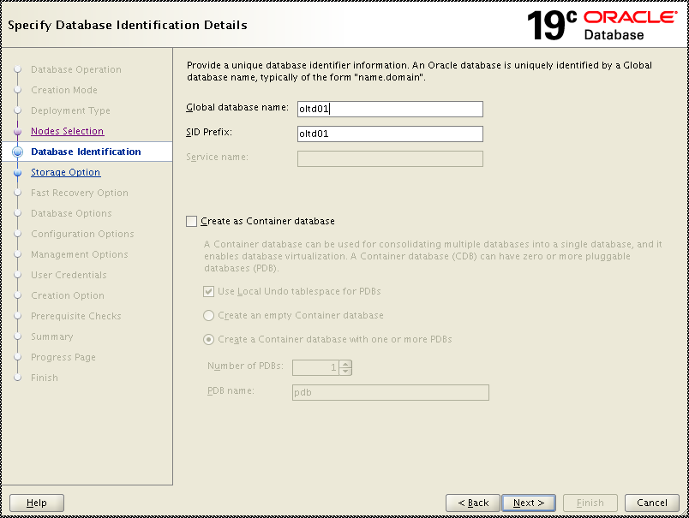

Uncheck “Create as Container database’s”

In the Global Database Name and SID fields enter the name of the database being created. Click on the “Next” button.

*************!!! STOP !!! *************

************* Please input lower case SID name, such as oltd01. *************

************* !!! ALERT !!! *************

Click “Use following for the database storage attributes”.

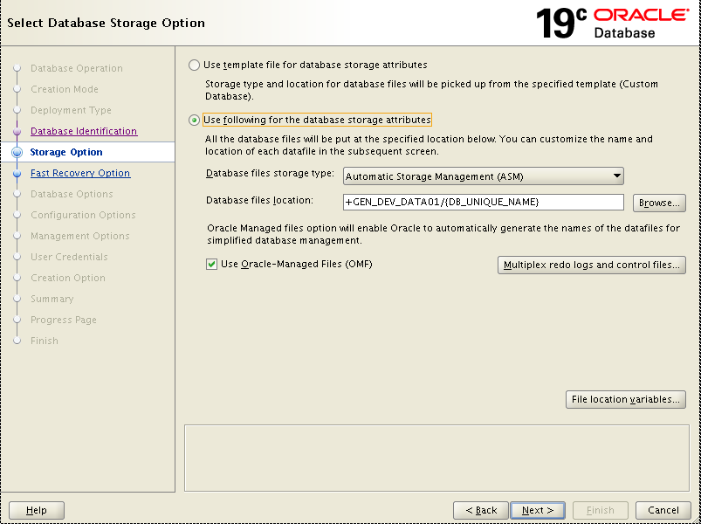

Click “Multiplex redo logs and control files”, input DATA and FRA related ASM disk groups then click “OK”. For example,

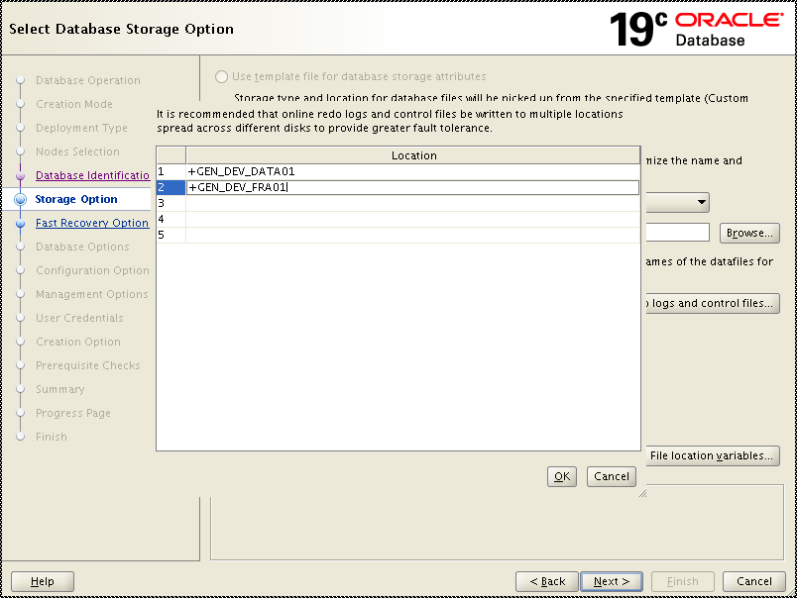

Click “OK”

Click “File location variables” to verify the file location. Click “OK” button and the “Next” button

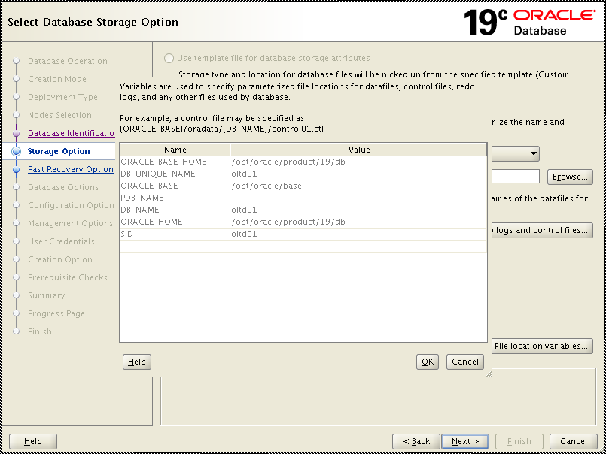

Click “OK”

Click “Next”

Check “Specify Fast Recover Area” and “Enable Archive”. And click

“Edit archive mode parameters”.

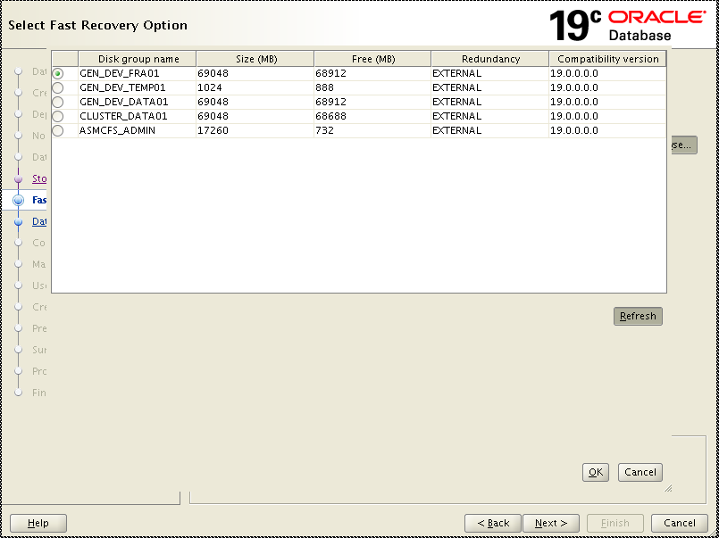

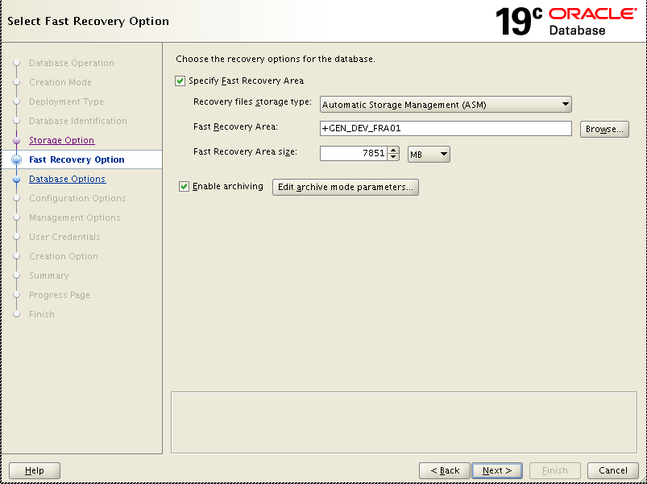

Click “Edit archive mode parameters”.

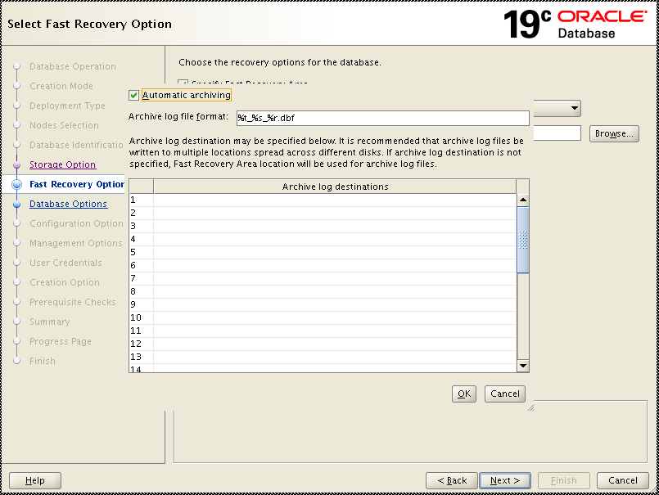

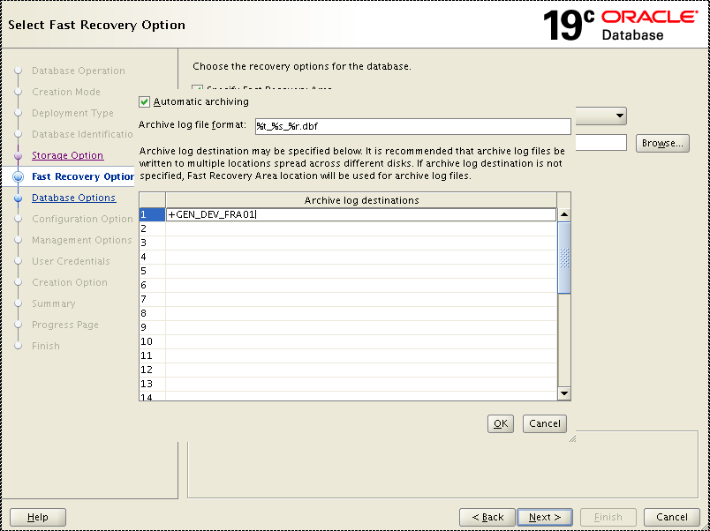

Input “FRA related ASM disk group” and click “OK”.

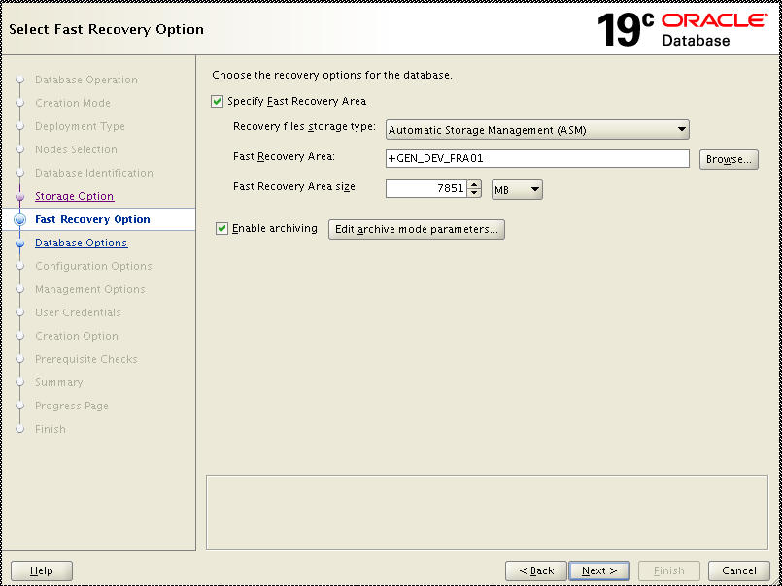

On the next screen,

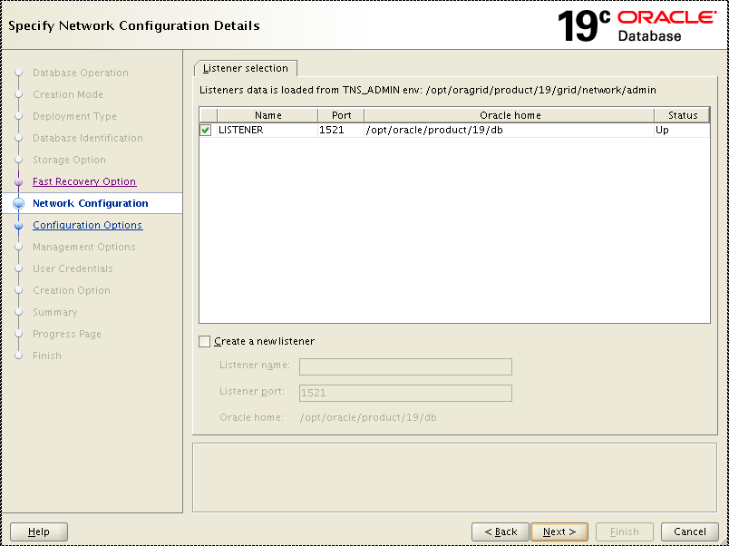

Select the listener that is running as LISTENER on port 1521 that was started as part of the grid installation. Click on the “Next” button.

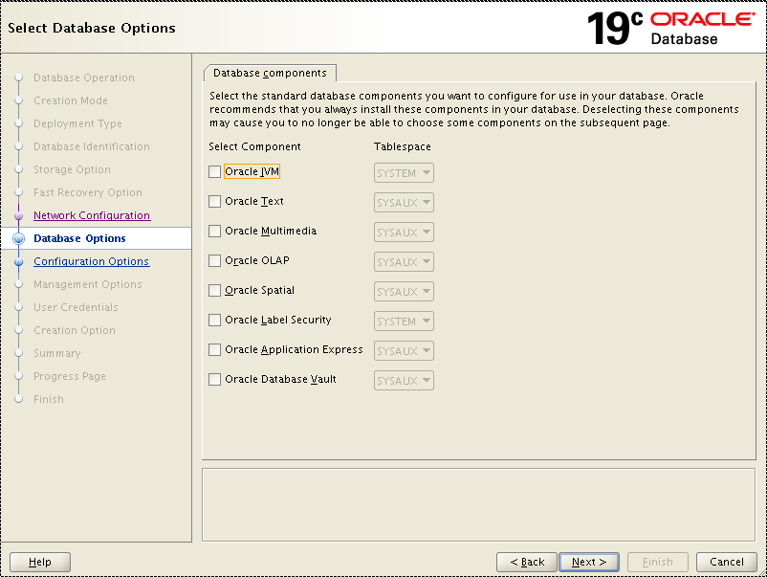

Uncheck all the listed components which we normally do not use. However, if any of these components are needed and we do have license from the requirement, then DBA needs to select it.

Click “Next”.

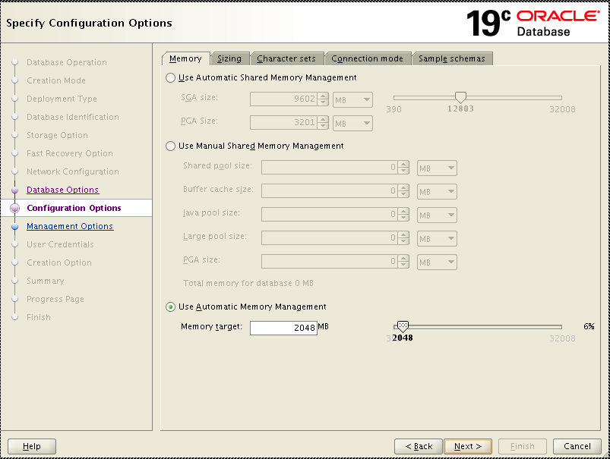

On the Memory Tab set the max memory setting to what is required for the database and applications being supported and click the check box next to “Use Automatic Memory Management” to enable AMM on the database.

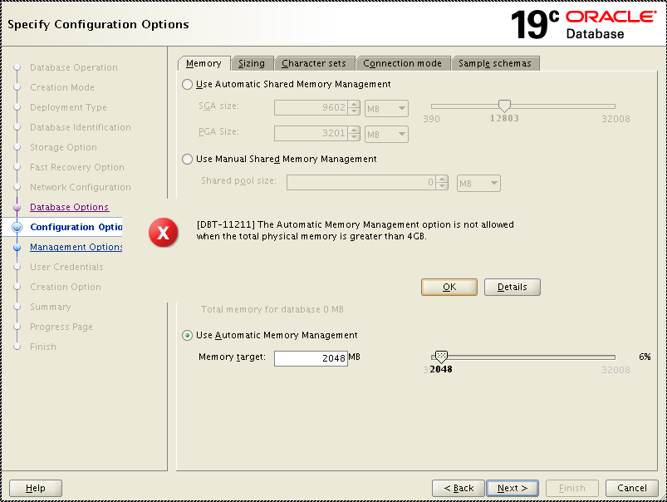

Oracle 19c does not support AMM management when the physical memory is more than 4Gb. In general, our Linux server is allocated with 32GB at least. Hence, we can not use AMM. Instead, we can use ASMMs (Automatic Shared Memory Management).

Select “Use Automatic Shared Memory Management”. 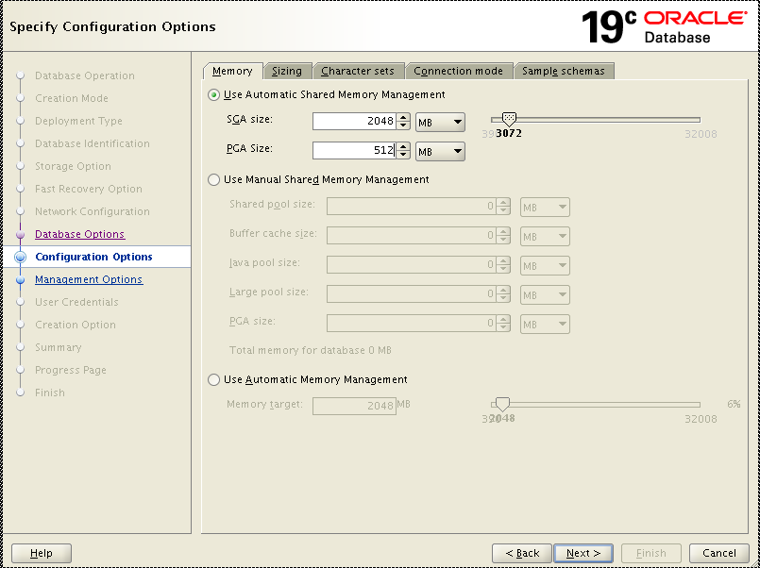

or

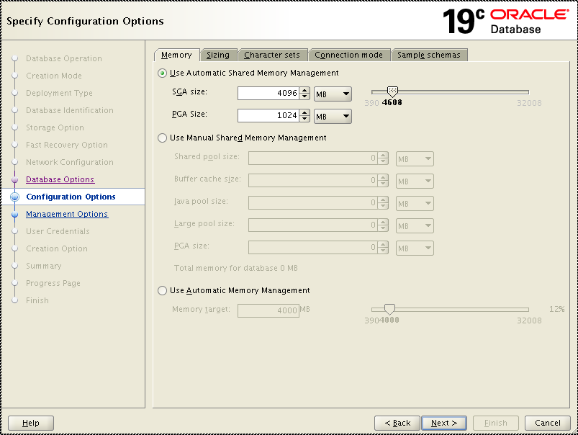

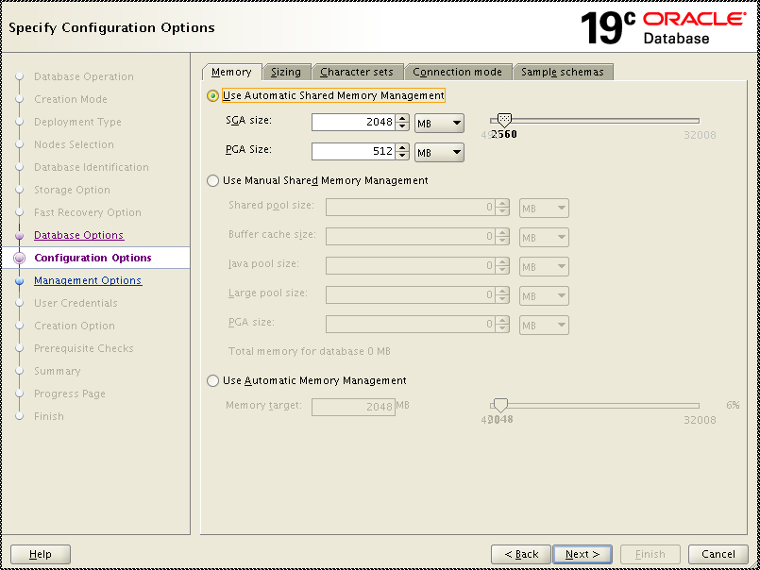

depending on the usage, input proper SGA size and PGA size. The ratio will be 4 to 1 initially.

Verify “Sizing” tab. On the sizing tab leave the block size at 8192 Bytes and set the number of processes to 640.

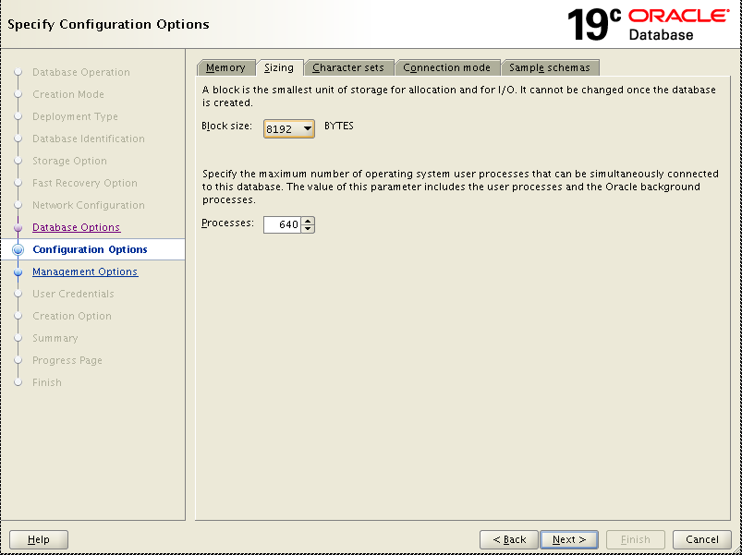

Click on the “Character Sets” tab.

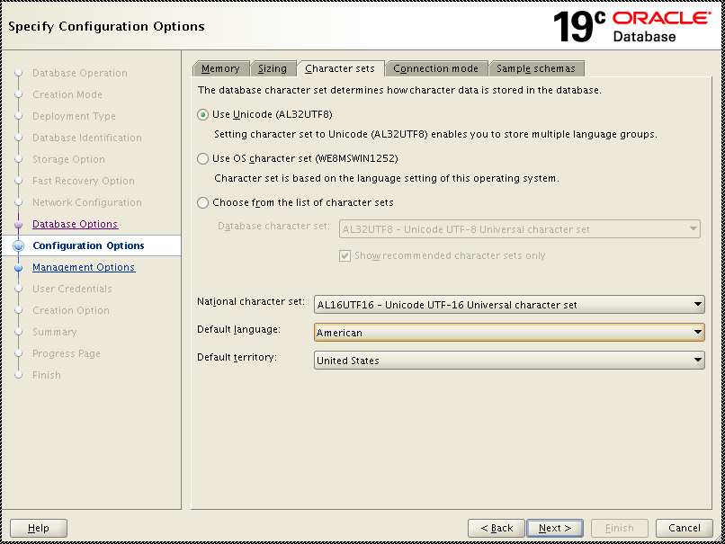

Click “Connection mode”. On this tab ensure that the “Dedicated Server Mode” radio button is selected.

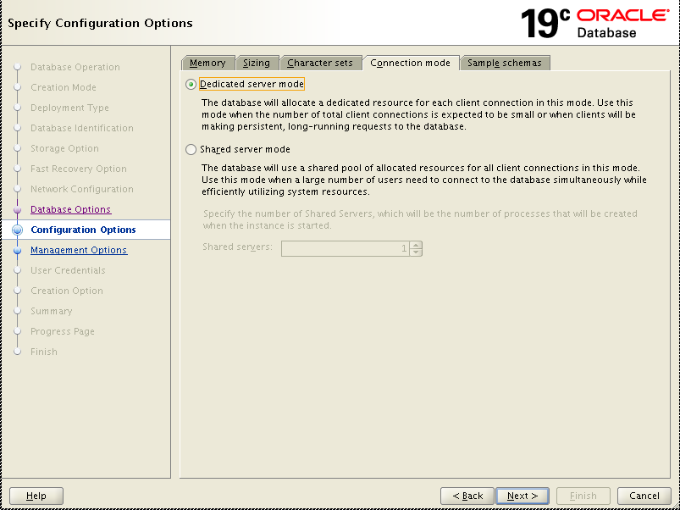

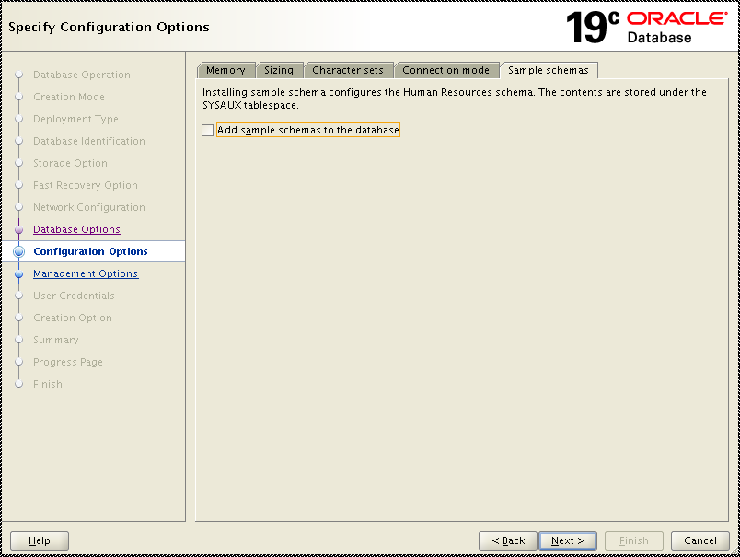

Verify “Sample schemas” to make sure “Add sample...” check box is not checked.

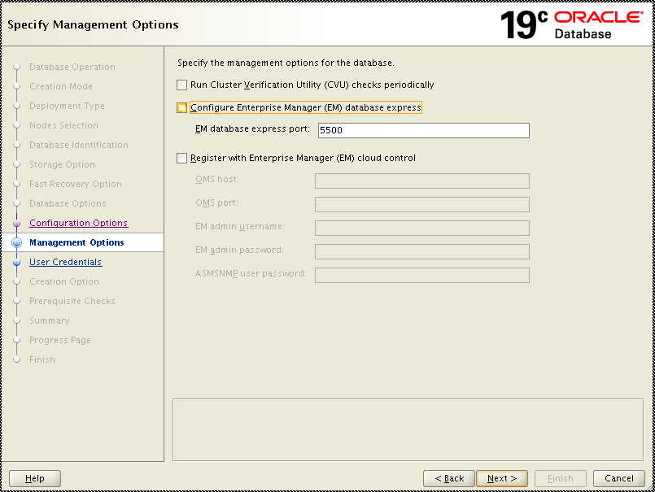

Uncheck “Run Cluster Verification…“, “Configure EM” and “Register with Enterprise”

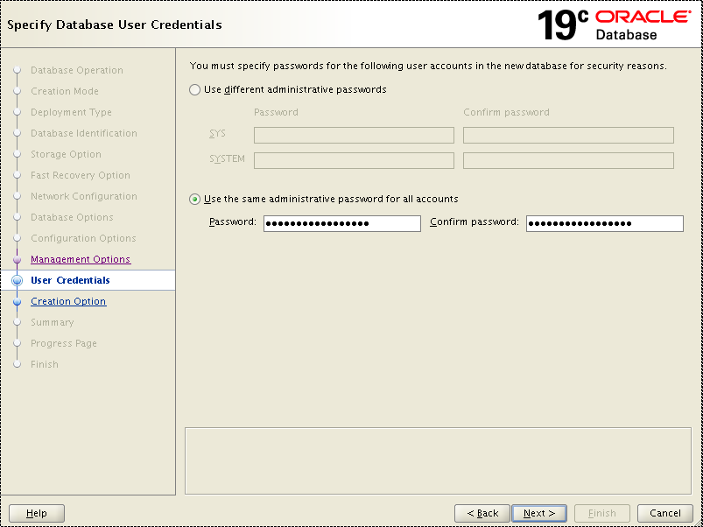

DBA_Database_<year> (Change it to use the latest annual password once everything is done.) Click “Next” button.

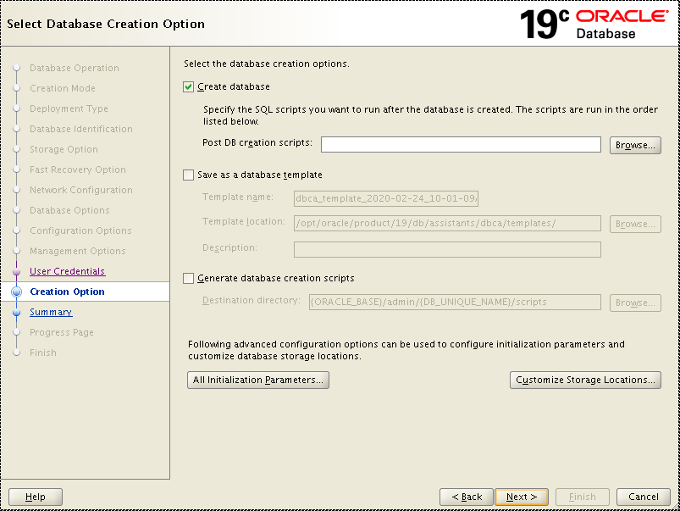

Click “Initialize Parameters”

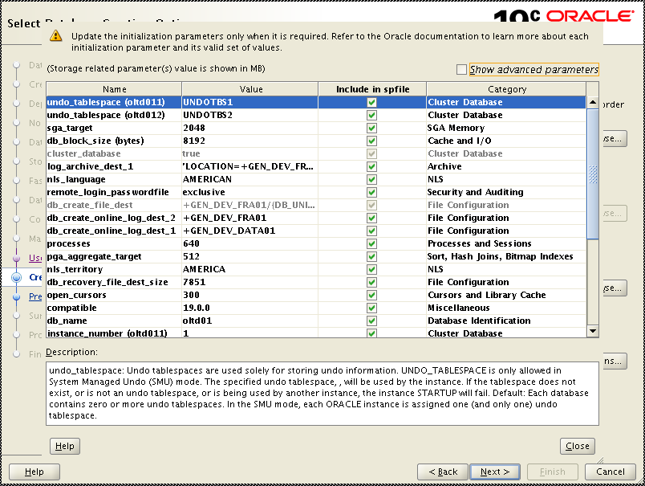

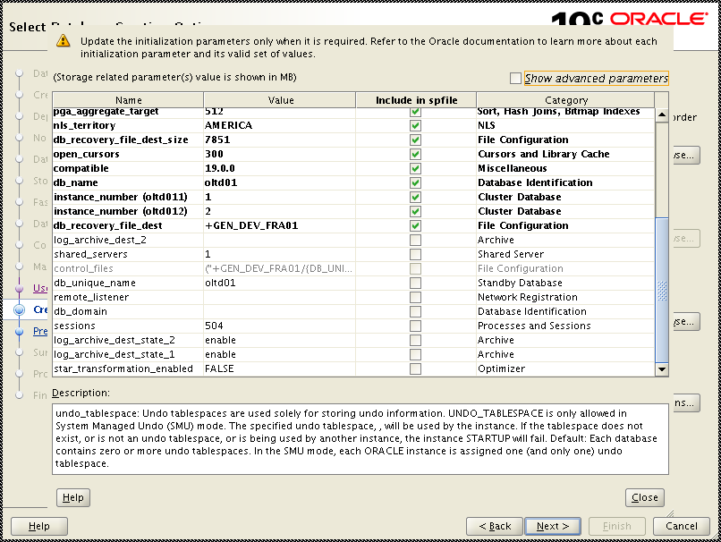

On the “All Initialization Parameters” screen click on the “Show Advanced Parameters” button and update the following parameters to be the values shown below with appropriate replacements where needed.

Audit_file_dest = /var/oracle/admin/<DBNAME>/audit

Audit_sys_operations = TRUE

Audit_trail = db

Control_management_pack_access = <Appropriate Value based on licenses owned>

Core_dump_dest=/var/oracle/admin/<DBNAME>/cdump

Diagnostic_dest=/var/oracle/admin/<DBNAME>

Filesystemio_options=setall

nls_length_semantics=CHAR

Once these have all been set click on the “Close” button to be returned to the Initializations Parameters screen and then click on the “Next” button.

Also, click “Customize Storage Locations”

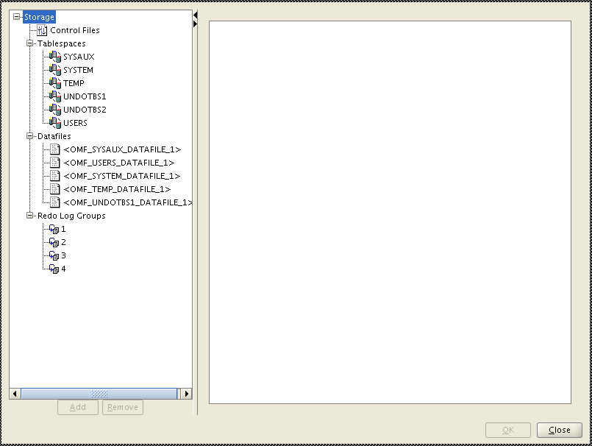

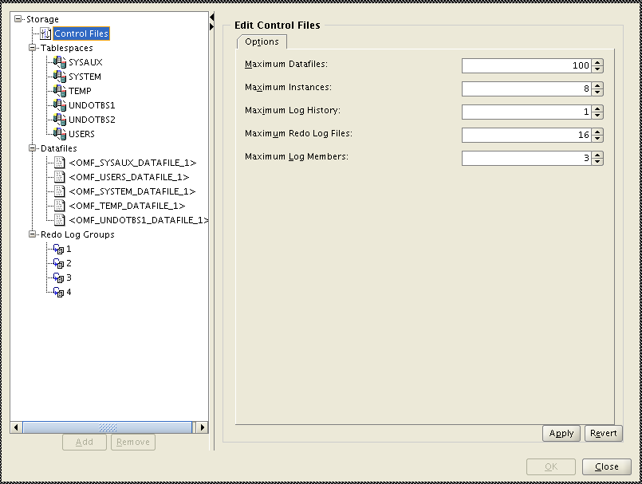

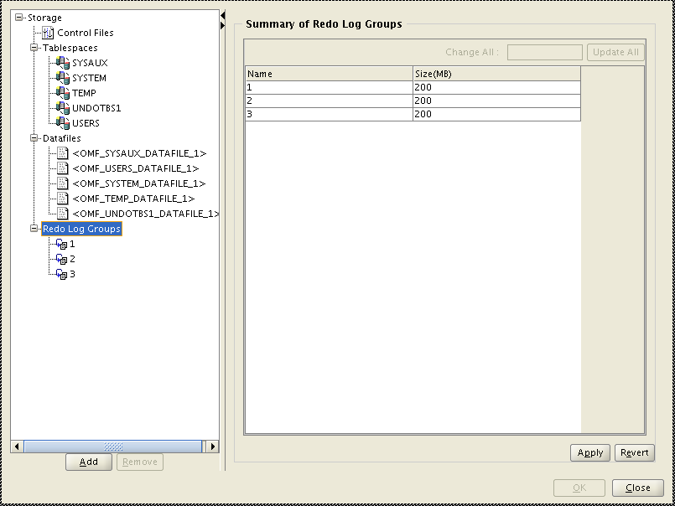

The following changes should be made:

1. The temp tablespace changed to be named DEF_TEMP as per the Marsh standards and sized appropriately for the application to be deployed.
2. The undo tablespaces need to size appropriately for the application to be deployed and be named DEF_UNDO_<DBNAME> to match our standards.
3. The system and sysaux tablespaces should be set to 2 GB each as a starting point since auditing is enabled and additional space will be required to hold audit records each day.
4. The user tablespace should be set to 2 GB as well.
5. Finally there should be 3 redolog groups created and sized appropriately for the application.

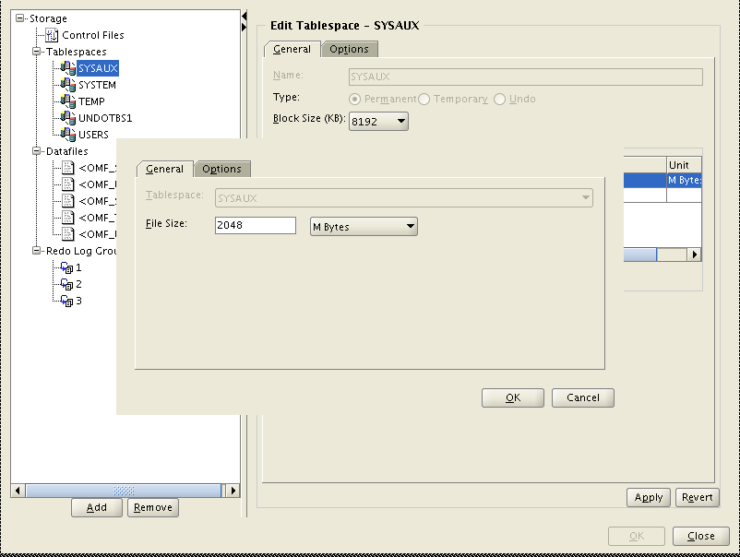

First set the SYSAUX tablespace to 2 GB. Click on the “Apply” button.

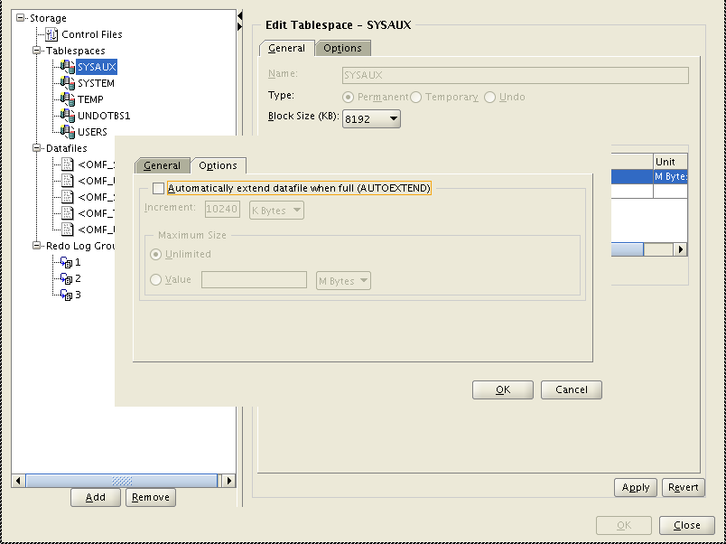

Uncheck “Automatically” and click “Apply”

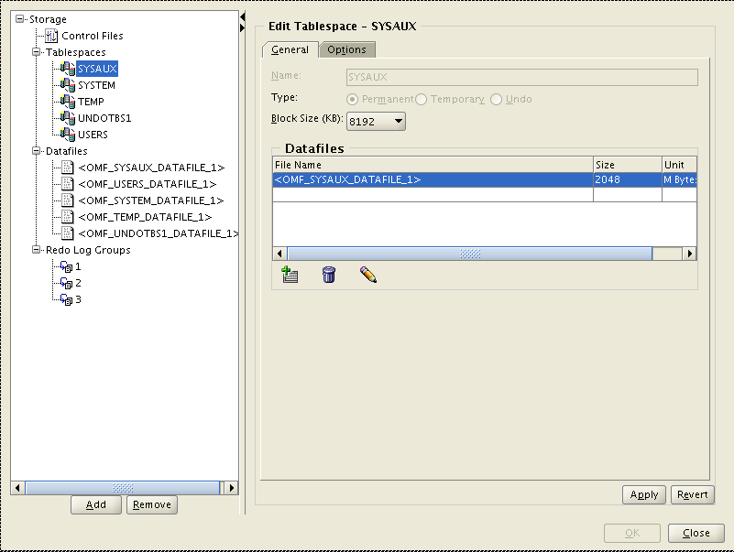

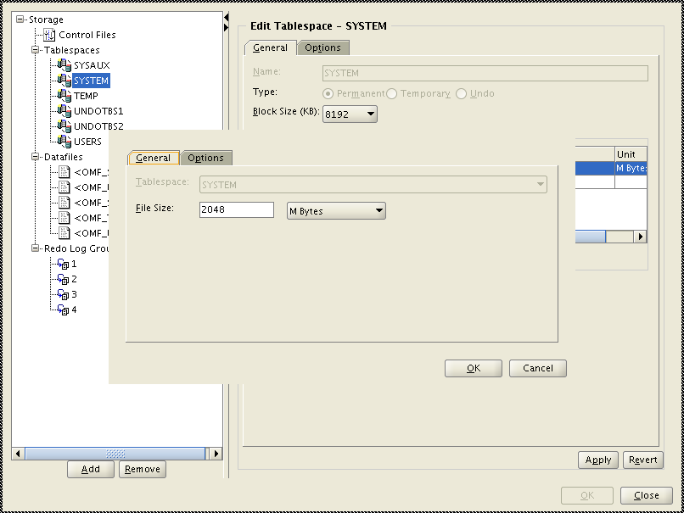

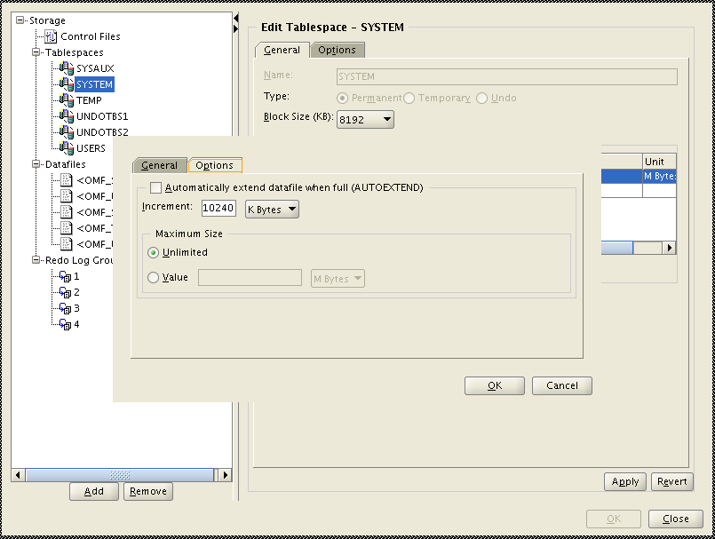

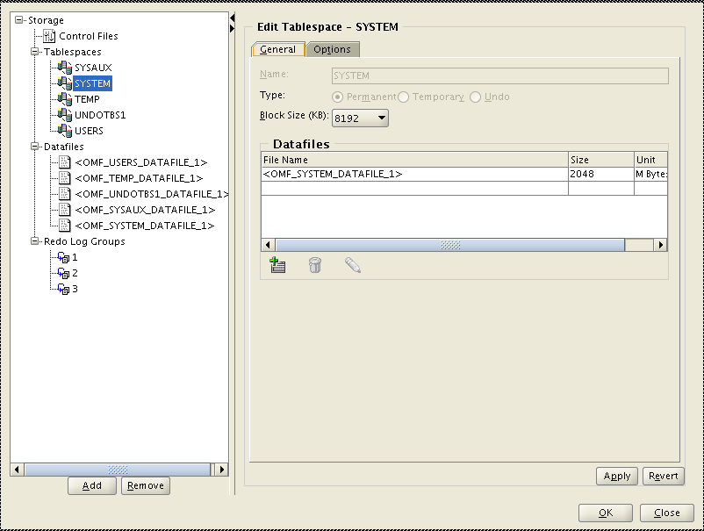

Set the SYSTEM tablespace to 2 GB. Also on the Options screen unselect the “Use Automatic Space Management” option for this tablespace. Click on the “Apply” button.

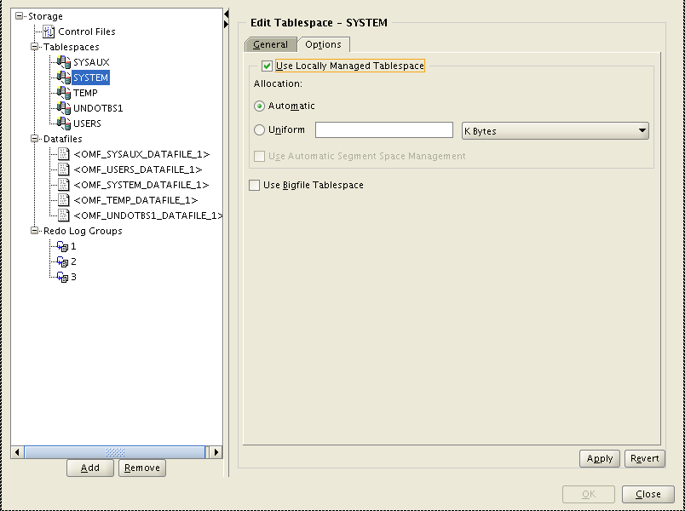

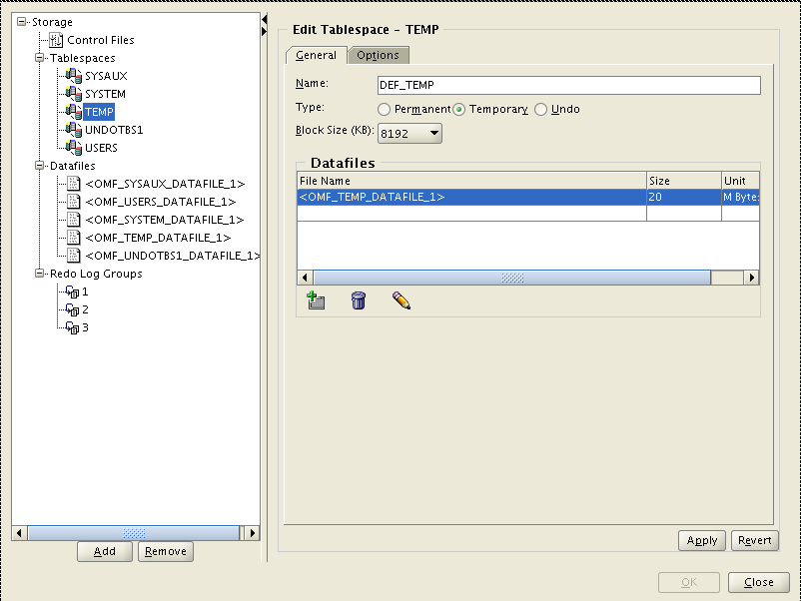

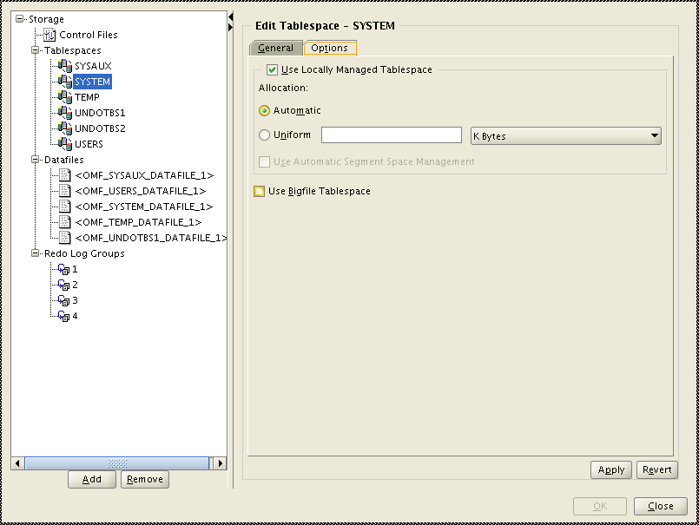

Click pencil icon (“Edit Datafile” button.)

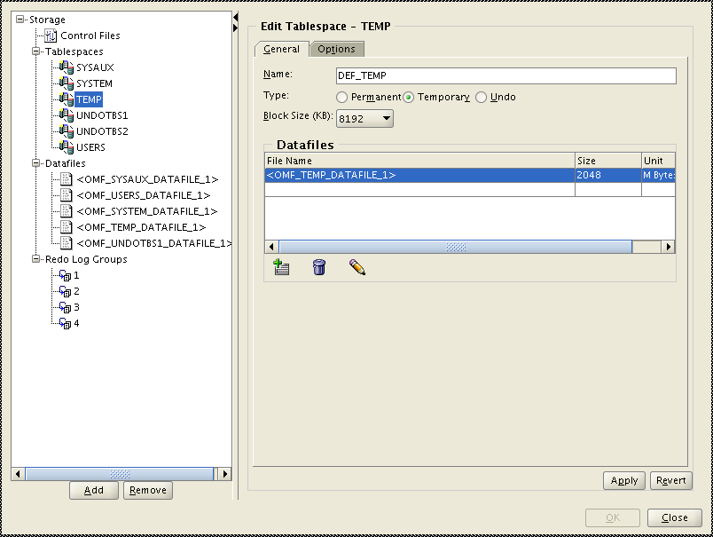-

Change to “DEF_TEMP”.

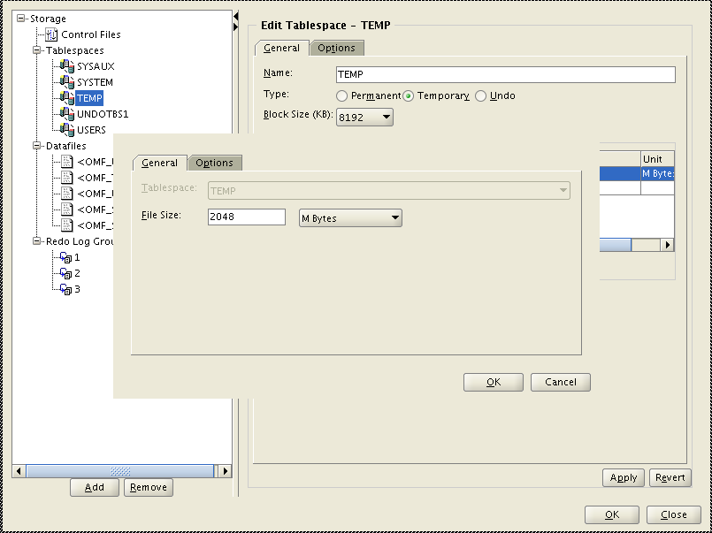

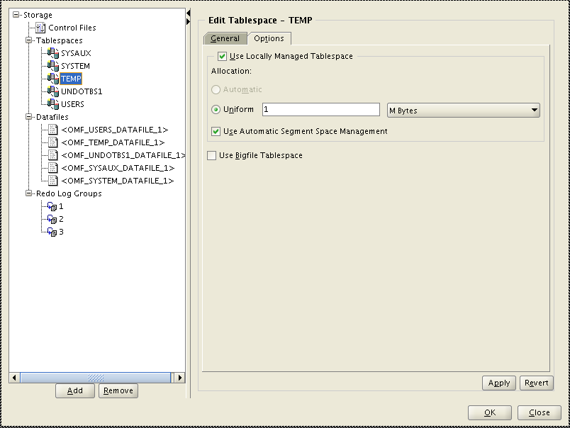

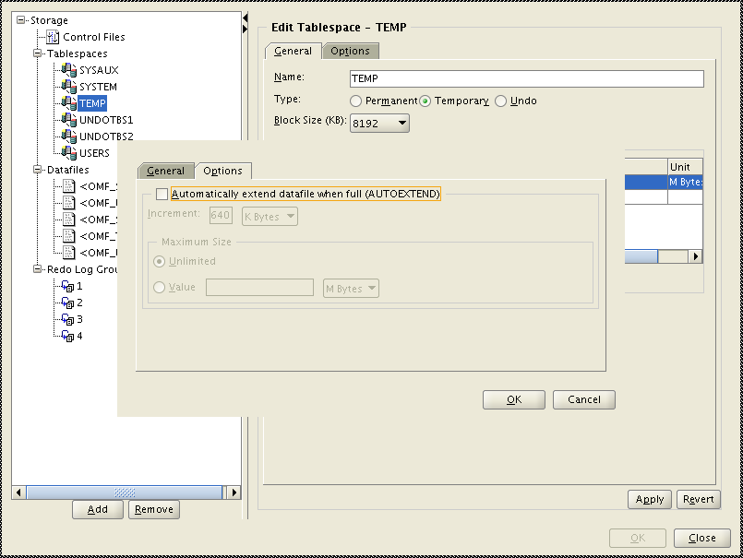

Set the TEMP tablespace to be called DEF_TEMP and sized appropriately for the application. On the Options screen the “Uniform Allocation” radio button must be selected and set it to use 1 MB allocations. Click on the “Apply” button. Also double check the DEF_TEMP is created under GEN_<env>_TEMP01 diskgroup, for example GEN_PROD_TEMP01.

Click “Apply”

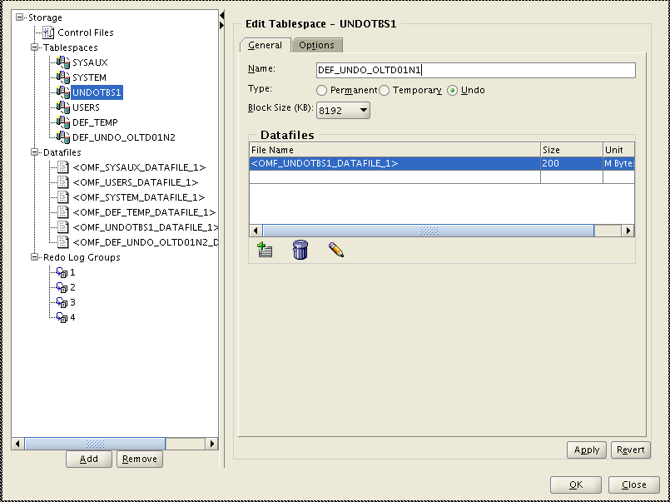

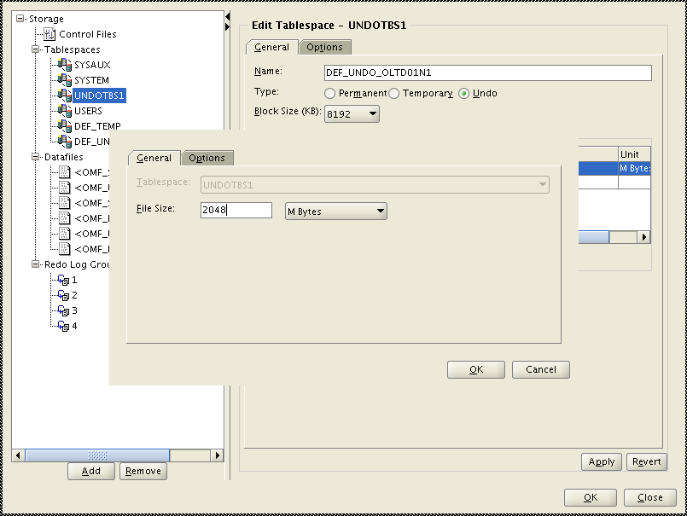

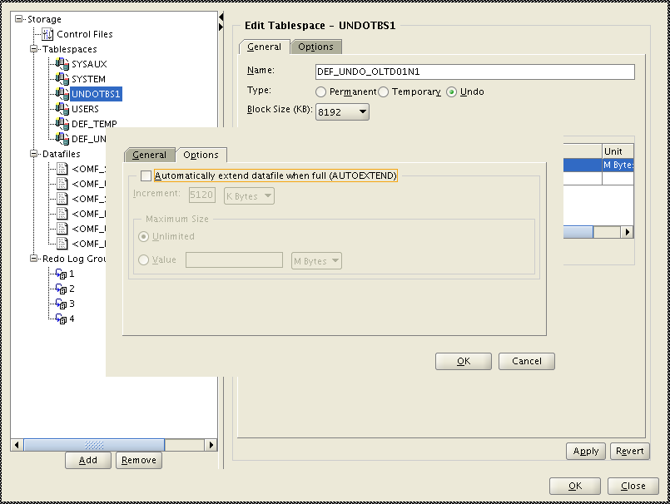

Click “Apply”

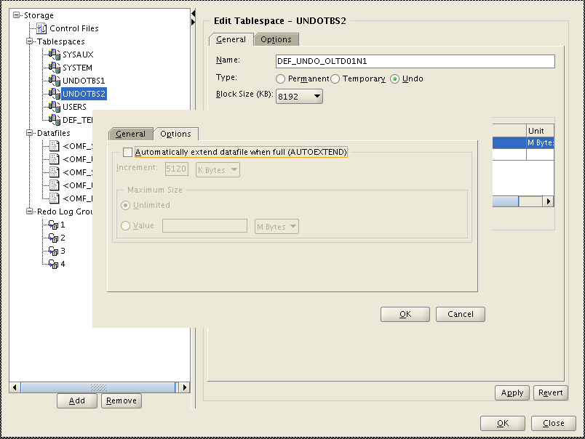

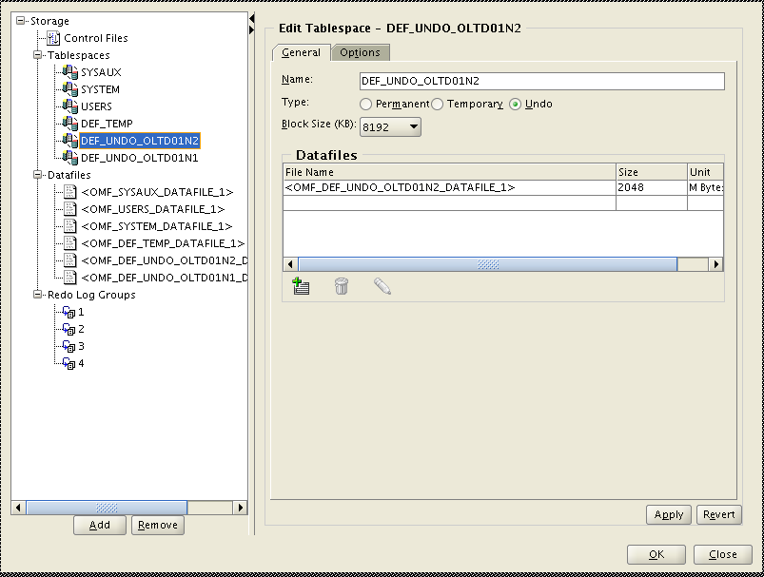

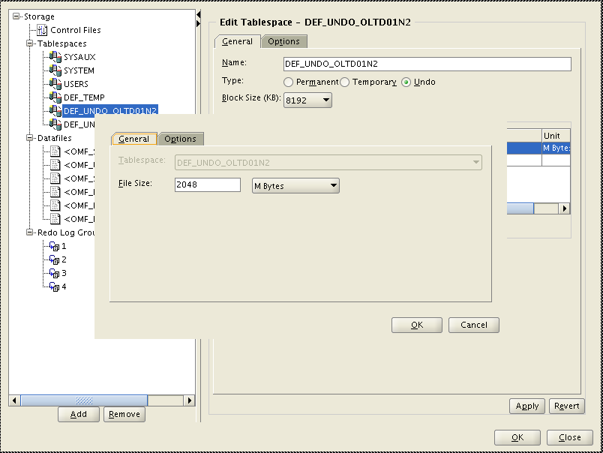

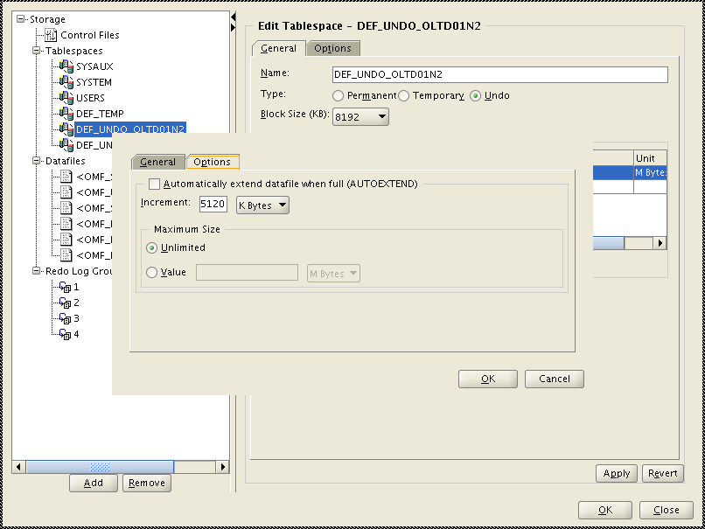

Click “Option” and uncheck “Automatically extend...”

Set the Undo tablespace to be DEF_UNDO_<DBNAME> (matching the value entered into the parameters) and be sized appropriately to handle the application load. Click on the “Apply” button.

Set the Users tablespace to be at 2 GB. Click on the “Apply” button.

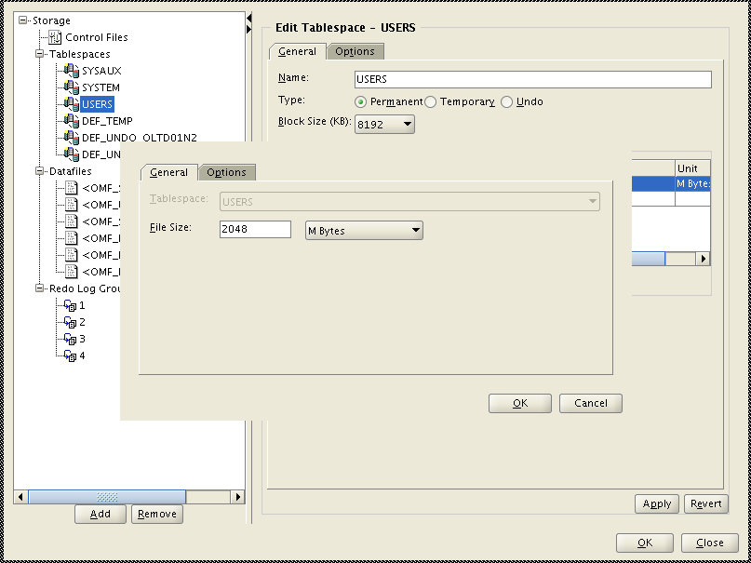

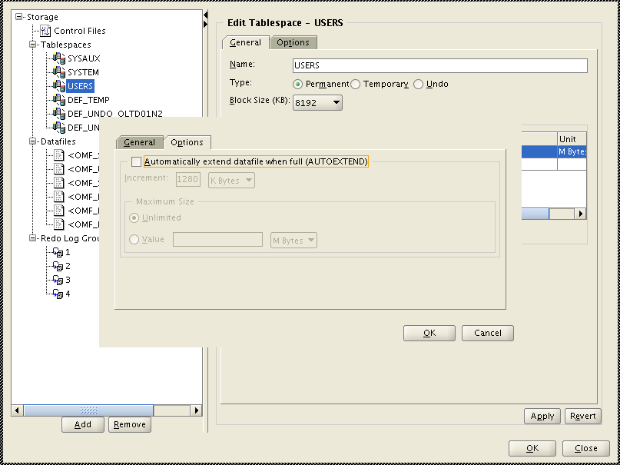

Next verify that each data file listed is set so that it will not auto-extend by unchecking the box for “Automatically extend datafile when full (AUTOEXTEND)” on the options screen. Click on the “Apply” button after changing each datafile.

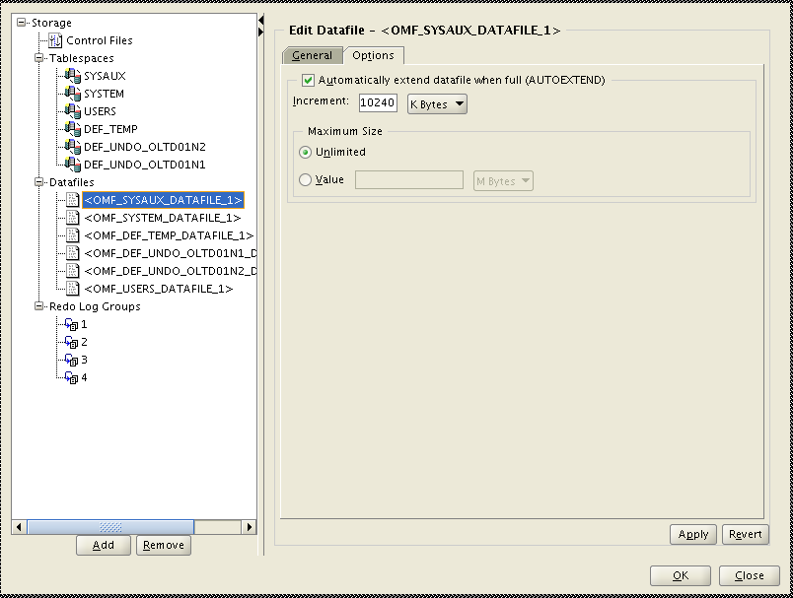

Click “Apply”

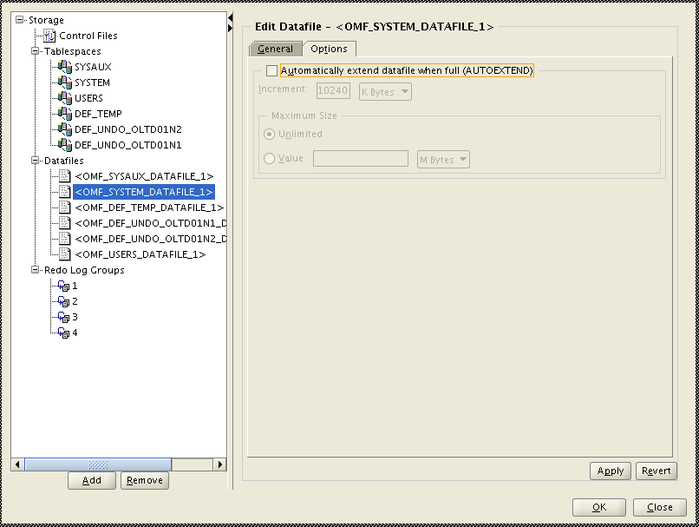

Click “Apply”

The final piece to set up here will be to configure the redolog groups to be sized appropriately and have sufficient numbers of groups. 3 groups will need to be created and they should be sized to allow for redolog switches to occur once every 15 minutes, each group should contain 2 members duplexed on the DATA and FRA disk groups that the database is using. Click on the “Apply” button after making appropriate changes. Once these are all completed click on the “OK” button to close the sub-screen and return to the Creation Options screen. Click on the “Next” button.

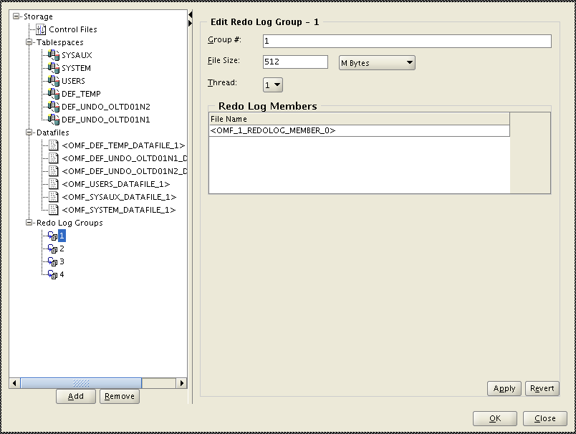

Change to 512 MB for each log group and click “Apply”.

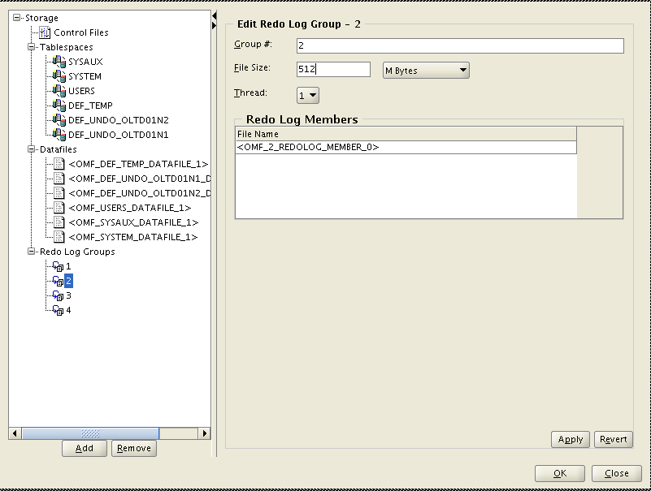

Change to 512 MB for each log group and click “Apply”.

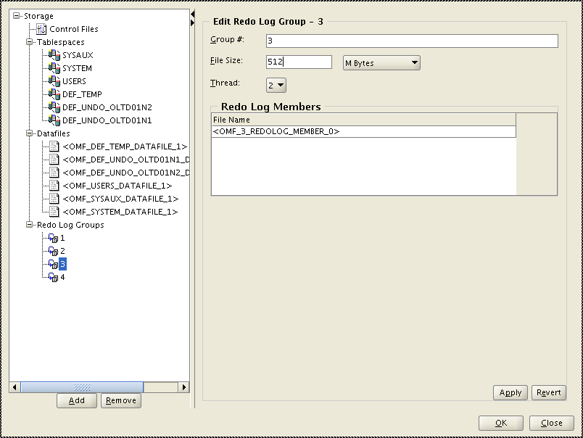

Change to 512 MB for each log group and click “Apply”.

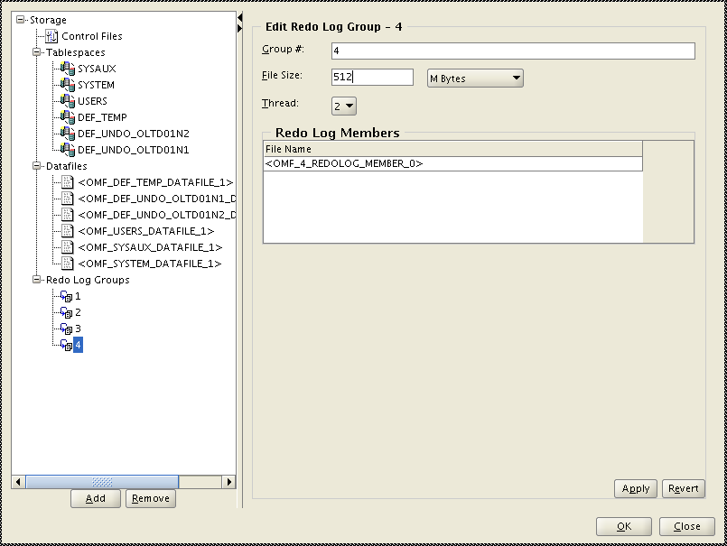

Change to 512 MB for each log group and click “Apply”.

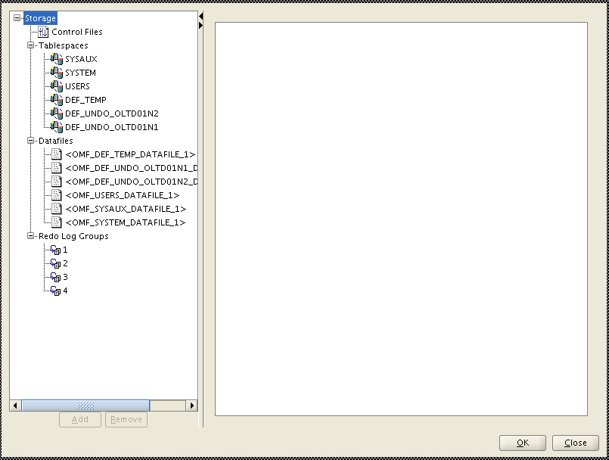

Click “OK”

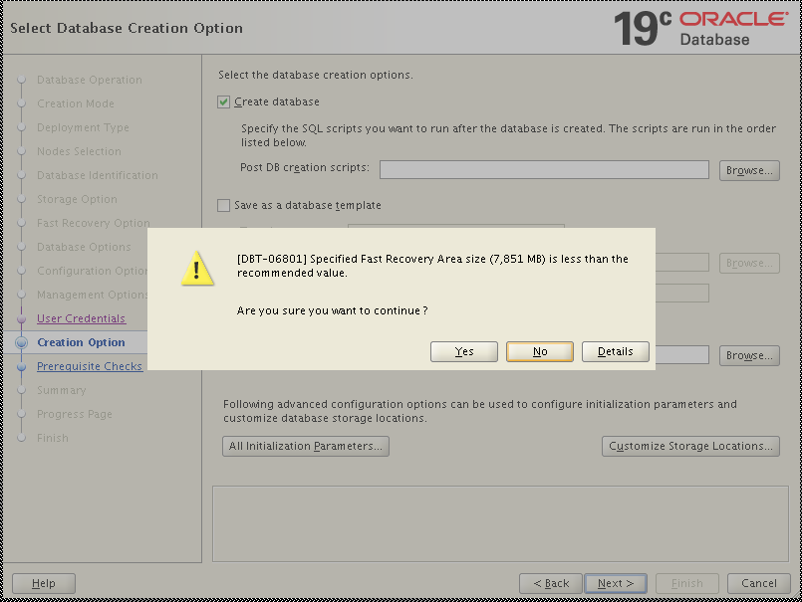

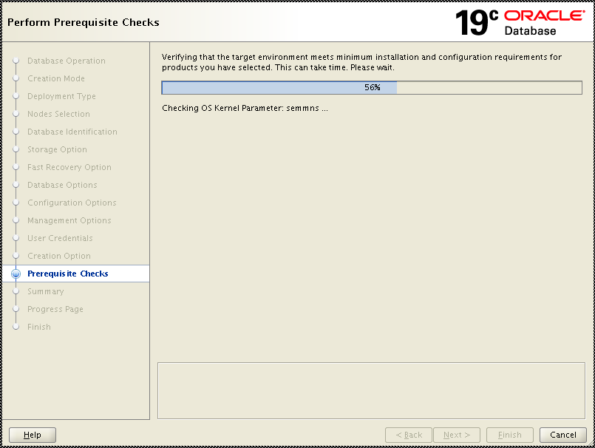

There should be no failures on the prerequisite checks screen and the summary screen will appear that will show you all of the options that have been selected to use for creating the database. Review this information to ensure it is correct and when ready click on the “Finish” button to create the database.

Once the database creation completes the below screen will be presented. Click on the “Close” button.

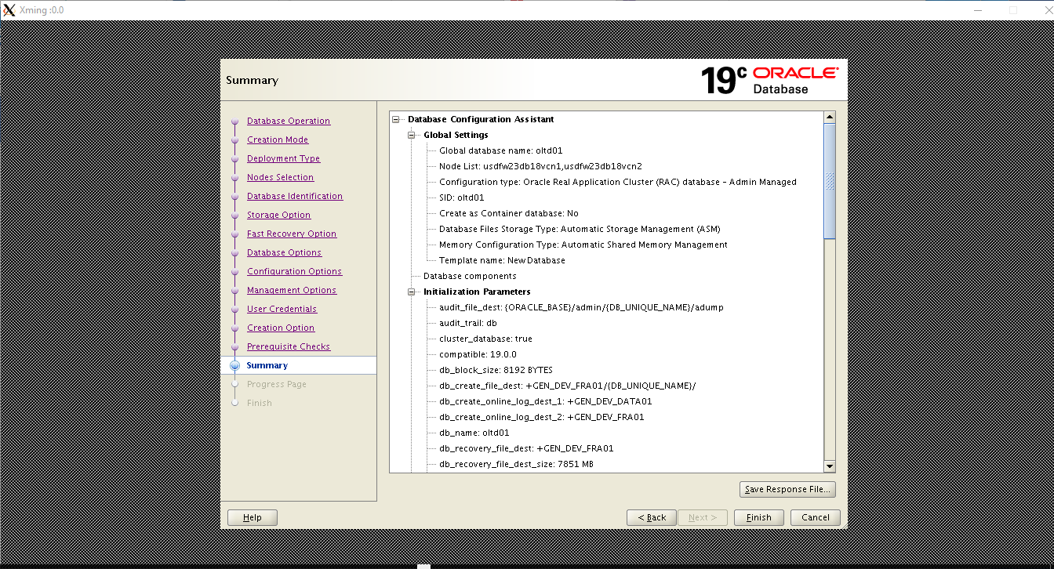

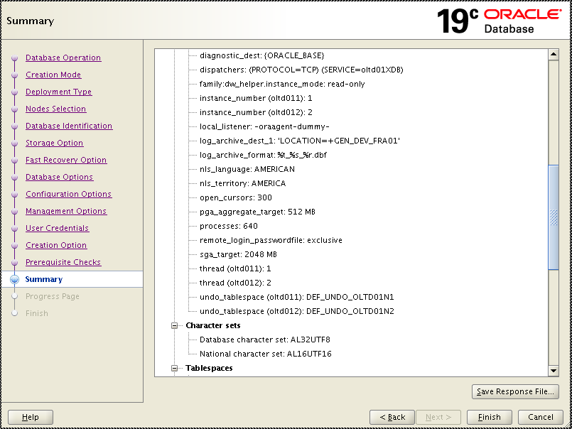

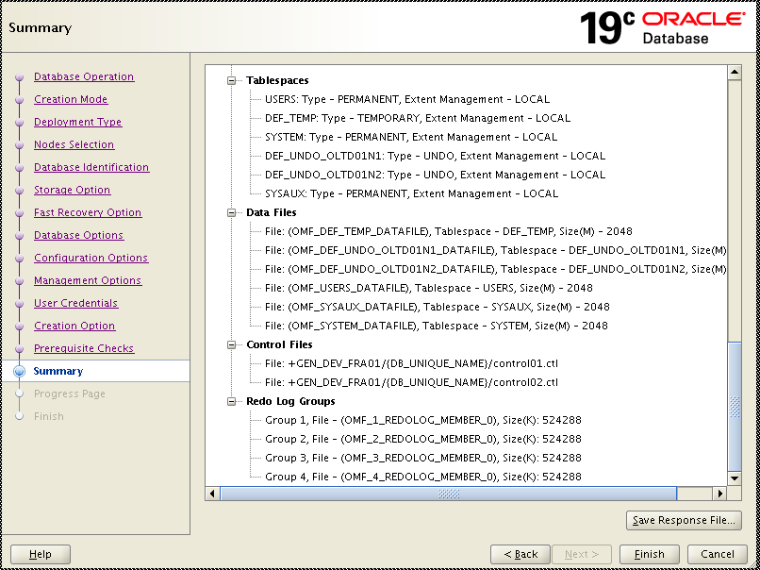

Click “Finish”

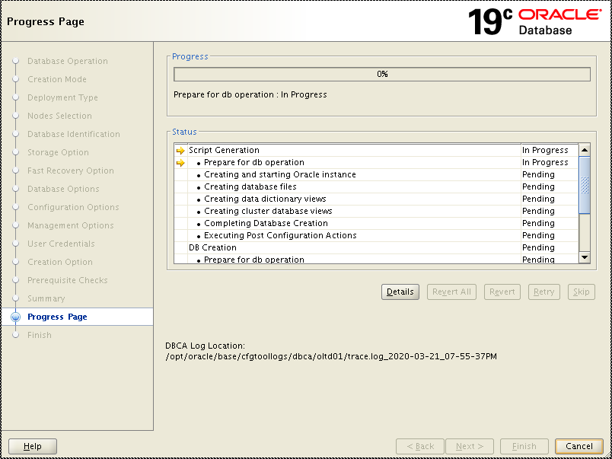

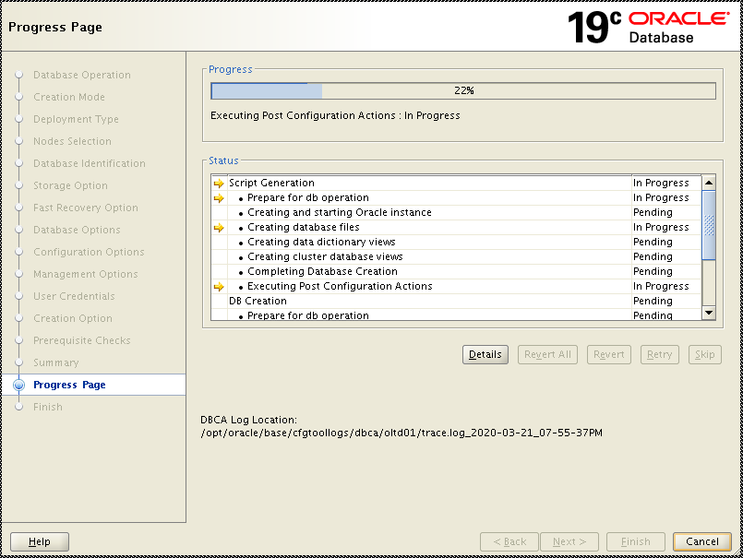

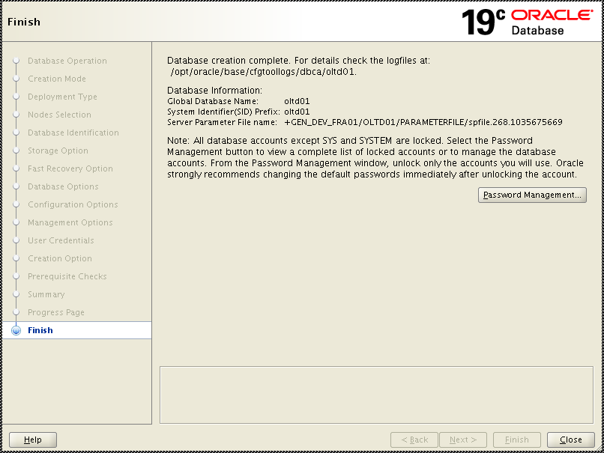

(Please note that 2nd control should be in FRA related ASK diskgroup, for example, +GEN_DEV_FRA01. Here is not updated due to limitation of ASM LUNS allocation in sandbox.)

Click “Finish” button.

Click “Password Management”

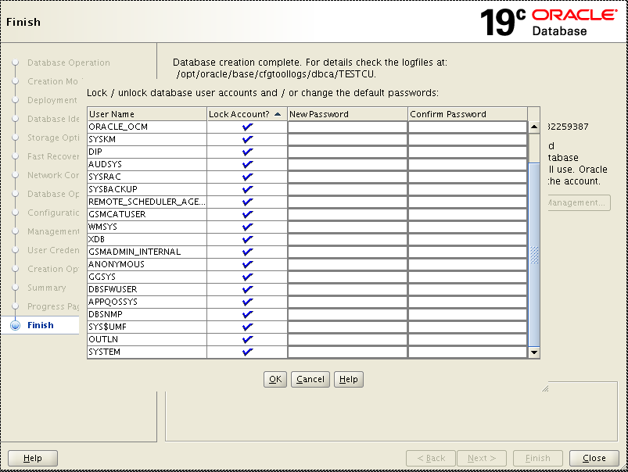

Click “All Initialization Parameters” button to verify the parameters.

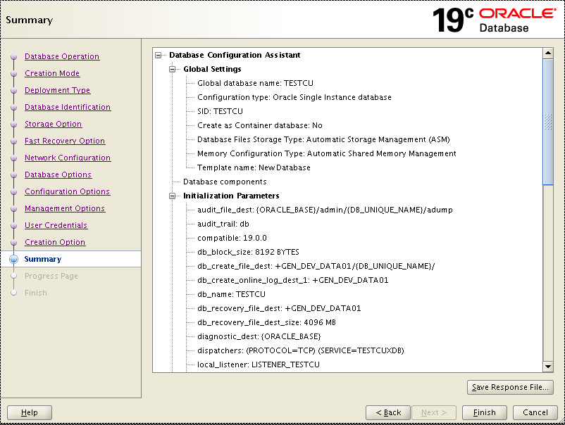

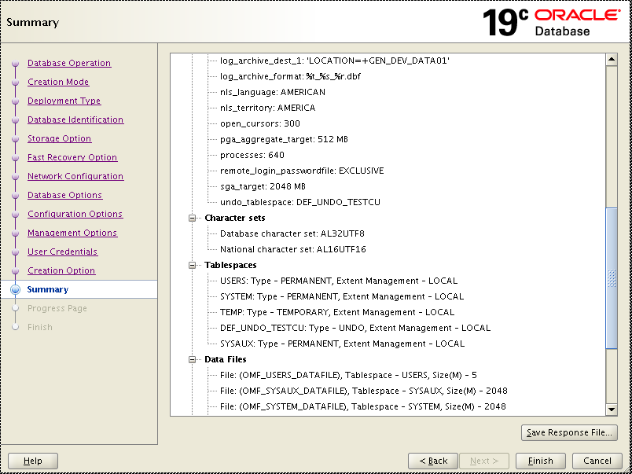

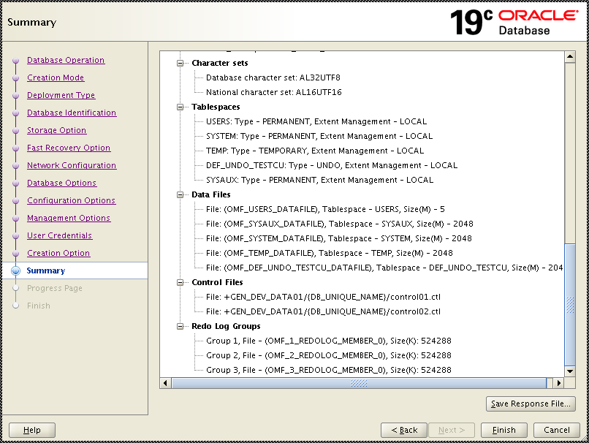

Click “Finish”

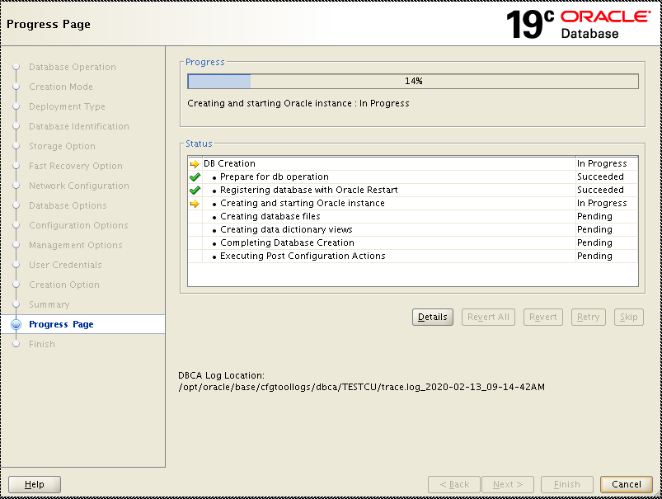

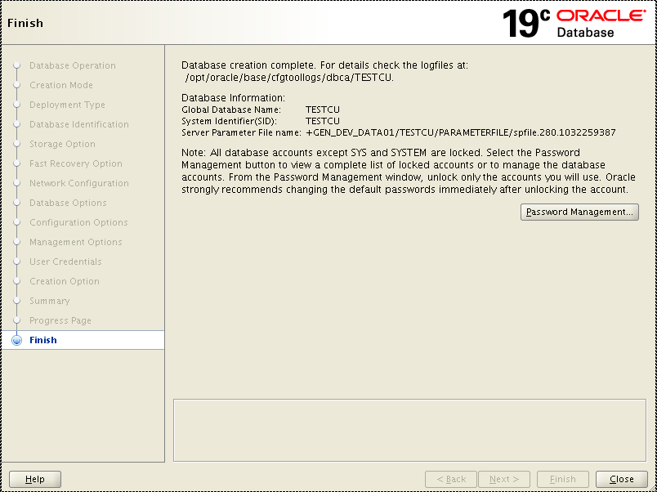

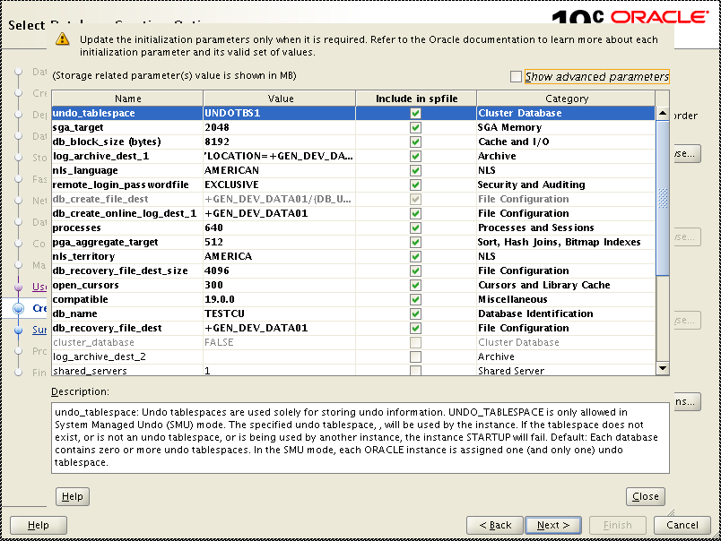

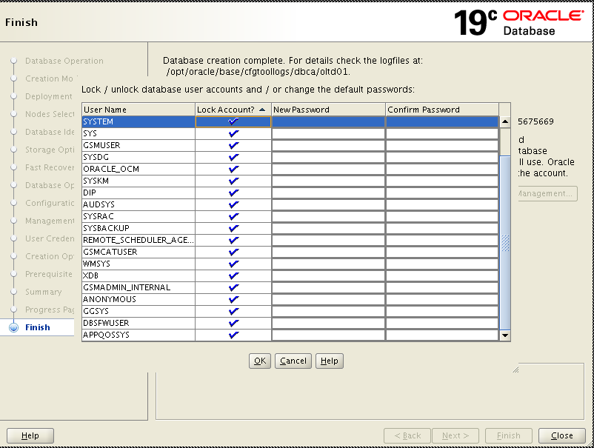

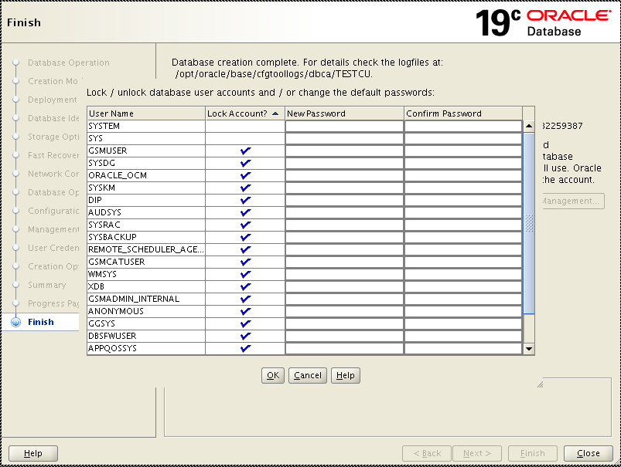

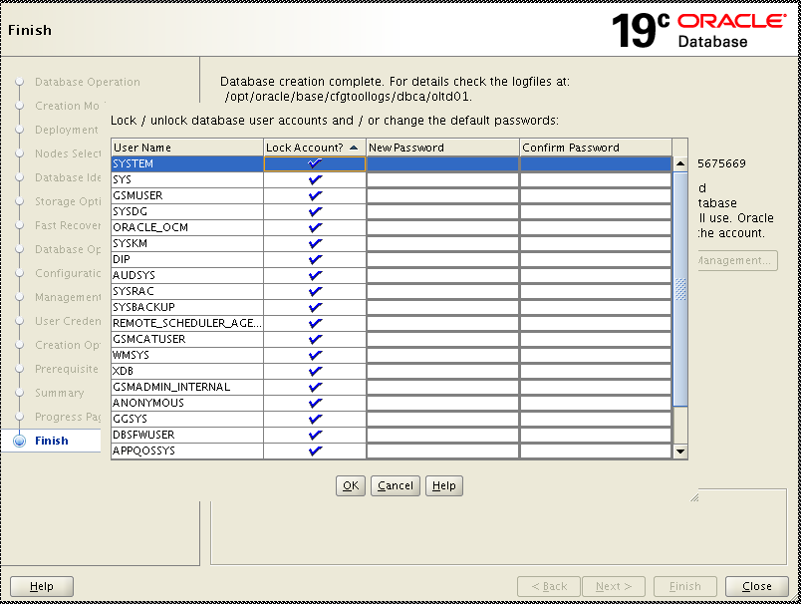

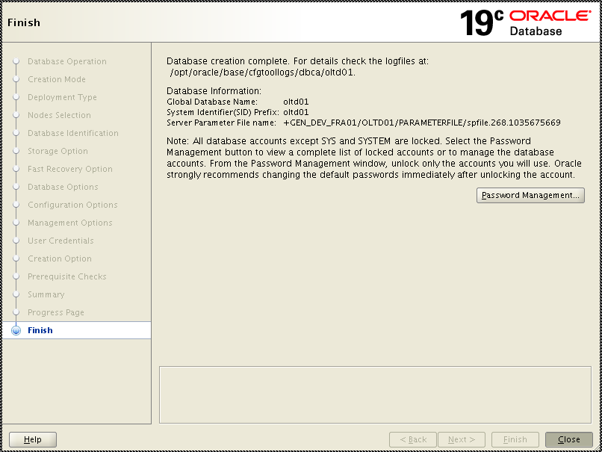

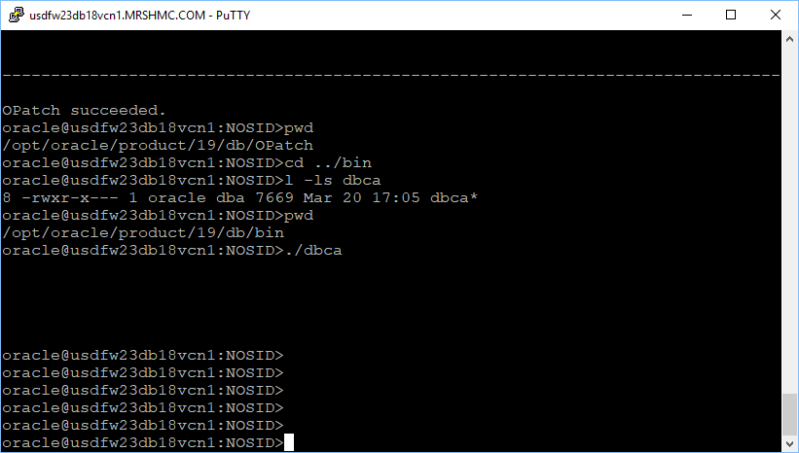

1. Post Activities of DB Creation.

* Lock “SYSTEM” account.

alter user system account lock;

* Lock “SYS” account.

alter user sys account lock

*

ERROR at line 1:

ORA-40365: The SYS user cannot be locked while the password file is in its

current format.

orapwd file=$ORACLE_HOME/dbs/orapwtestcu format=12.2

alter user sys account lock;

(Change the latest password once everything is done)

alter user sys identified by <latest sys’s pwd>

* **Set the nls_length_semantics for the database to be CHAR**

alter system set nls_length_semantics = CHAR scope=both;

Verify the change.

SQL> select PARAMETER, value from v$nls_parameters where PARAMETER = 'NLS_LENGTH_SEMANTICS';

* **Disable the following Autotask jobs**

SQL> EXEC DBMS_AUTO_TASK_ADMIN.DISABLE(client_name=>'sql tuning advisor', operation=>NULL, window_name=>NULL);

PL/SQL procedure successfully completed.

SQL>

SQL> EXEC DBMS_AUTO_TASK_ADMIN.DISABLE(client_name=>'auto space advisor', operation=>NULL, window_name=>NULL);

PL/SQL procedure successfully completed.

SQL>

SQL> EXEC DBMS_AUTO_TASK_ADMIN.DISABLE(client_name=>'auto optimizer stats collection', operation=>NULL, window_name=>NULL);

PL/SQL procedure successfully completed.

SQL>

* **Disable Adaptive plans**

OPTIMIZER_ADAPTIVE_PLANS=TRUE by default                    ➔ Set it to FALSE

ALTER SYSTEM SET OPTIMIZER_ADAPTIVE_PLANS=FALSE  SCOPE=both

(This has been disabled by default:

ALTER SYSTEM SET OPTIMIZER_ADAPTIVE_STATISTICS=FALSE by default

)

* **Disable default policies for unified audit and cleanup unified audit records**

exec DBMS_AUDIT_MGMT.FLUSH_UNIFIED_AUDIT_TRAIL;  
  
prompt clean audit trail  
  
BEGIN  
   DBMS_AUDIT_MGMT.CLEAN_AUDIT_TRAIL(  
     AUDIT_TRAIL_TYPE           =>  DBMS_AUDIT_MGMT.AUDIT_TRAIL_UNIFIED,  
     USE_LAST_ARCH_TIMESTAMP    =>  FALSE,  
     CONTAINER                  => dbms_audit_mgmt.container_current);  
END;  
/

NOAUDIT POLICY ORA_SECURECONFIG;  
noaudit policy ORA_LOGON_FAILURES;

(

SQL> exec DBMS_AUDIT_MGMT.FLUSH_UNIFIED_AUDIT_TRAIL;

PL/SQL procedure successfully completed.

SQL> prompt clean audit trail

clean audit trail

SQL>

/

2 3 4 5 6 7

PL/SQL procedure successfully completed.

SQL>

SQL> NOAUDIT POLICY ORA_SECURECONFIG;

Noaudit succeeded.

SQL> noaudit policy ORA_LOGON_FAILURES;

Noaudit succeeded.

SQL>

* **Follow with DBA internal audit package and administration scripts deployment. Also make sure below parameters’ value are using respective subdirectories under /var/oracle/admin filesystem.**

audit_file_dest

background_dump_dest

core_dump_dest

user_dump_dest

Also, correct DEF_TEMP’s temp file location if it is not in ASM TEMP related disk group.